

Welcome Letter

Welcome to the “Houston…We Have a Launch” Tournament!

We are very excited to be hosting a tournament once again at the Apex Field House in Arvada.

Apex Field House is located at 5724 Oak St. Arvada, CO. 80002 off 58th and Oak St.

We ask everyone to please ensure we are on our best behavior, pick up after your dog, and always have your dog on leash if not running flyball. Please only potty your dogs on the designated grass areas and not on the rocks. Do not walk on rocks, only on designated sidewalks or roadways.

Please follow all building rules. There is no food or drink allowed inside the turf (racing) area nor alcohol in the building.

This is a beautiful building with an amazing flooring that benefits both dogs are their humans, but it does have some challenges.

- No set up until Saturday morning (7:15 am building opens for crating, no earlier) due to adult sports leagues the night before.
- This is not an event facility and there are no tables or chairs available, so please bring your own.
- Limited amount of electrical outlets, so make sure you have extension cords and power strips with you and please share the limited outlets with other clubs.
- There will be a designated walkway through the crating area so people and dogs can get through to access the potty areas. Please make sure to keep the walkway clear throughout the weekend.
- There is no RV parking. There is an RV park on 44th and Ward Rd and at the Jefferson County Fairgrounds (10 minutes away). Please contact me if you have any questions.
- We will have 2 separate trash containers label “dog poop”, please only use those ones since their trash is very easy to confuse with the recycle containers and we do not want to make those dirty.

If you have any questions, problems, or suggestions, please see Susi Evans (TD) susievans@comcast.net, Julie Field (TS) julzf@hotmail.com or anyone with a Launch shirt.

Format & Racing
Divisions have been posted and racing schedules will be posted soon on the Region 19 site – www.region19flyball.com and in our site www.launchflyball.com.
Tournament scoring will be one point per heat won. For any tied heat, each team will receive 1 point. For tournament placement, ties will be broken by head to head wins. If still tied, then the fastest legal time of the day wins. Ties of three or more teams will be broken by the fastest legal time of the day.
This is a No Frills Tourney but we do have an awesome worker raffle. We will have 37 races on Saturday and 35 on Sunday, format for all teams is 4/4. There will be a 45 minute lunch break on Saturday and no lunch break on Sunday since we need to be out of the turf by 2:30pm.
We will have 5 minute breaks and back to backs all day so get ready for those. We will make sure everyone gets enough time, this is a result of the small number of entries but we are committed to make sure everyone has a good time.
Warm up time will be two minutes for the first race, one minute thereafter.
We will have mat time after racing on Saturday. Please contact Susi Evans at susievans@comcast.net to sign up for it. Each dog will get 5 minutes. There are limited spots so let me know as soon as you can. In addition, also let me know if the dog can work with other dogs and any other requirements you might need.

Saturday Tournament Hours & Schedule:
Building opens forcrating: 7:15 a.m.
Check-in: 7:45 a.m.
Measuring: 8:00 a.m.
Captains Meeting: 8:15 a.m.
Racing Begins: 8:30 a.m.
***45 minute lunch break TBD

Sunday Tournament Hours & Schedule:
Building opens: 6:30 a.m.
Check-in: 6:45 a.m..
Measuring: 7:00 a.m.
Captains Meeting: 7:15 a.m.
Racing Begins: 7:30a.m.
***No lunch break

Divisions & Racing Schedules will be posted on www.Launchflyball.com & www.Region19Flyball.com

General Information:
- Head Judge: Danny Fitts Relief Judge: Karl Ruetz.
- Tournament Director: Susi Evans susievans@comcast.net 303-949-3279
- Tournament Secretary: Julie Field julzf@hotmail.com
- Regional Director: Terry McCleantmcclean@yahoo.com, 307-760-7867
- Building is open to the public and free for spectators

Judging Schedule
Included with the racing schedule is a schedule for line and box judging each day. The judging schedule is listed by club based on the number of teams entered. Please coordinate with your teams: Some of you will be judging while one of your teams is racing. This is unavoidable because of the number of teams entered. We have a great worker raffle each day. If you see a chair empty, please help us out by filling it. The raffle tickets will distributed using the honor system. The more you judge, the more you can win. And we’ll all win by getting through racing more quickly.
There is one item you can start putting tickets in for on Saturday and Sunday and will be raffled on Sunday. It is very special item from Deede Pecora.


Food
There will not be any food available on site. No tables will be provided. Please bring your own table for your personal needs.
There are many restaurants on 58th East of Kipling about 5 minutes away. In addition there is also a Kroger grocery store .If you go South (right on Kipling from 58th) There are many other restaurants and a Natural Grocers.
Crating
All crating will be assigned. Crating will be open Saturday at 7:15am.

Facility:

Apex Field House

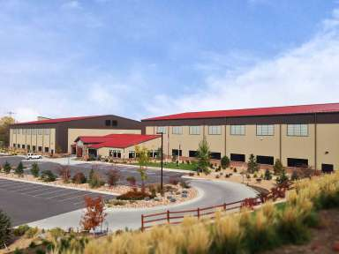
5724 Oak St. (We will be on the right field facing the door)
Arvada, CO 80002
303-431-9600
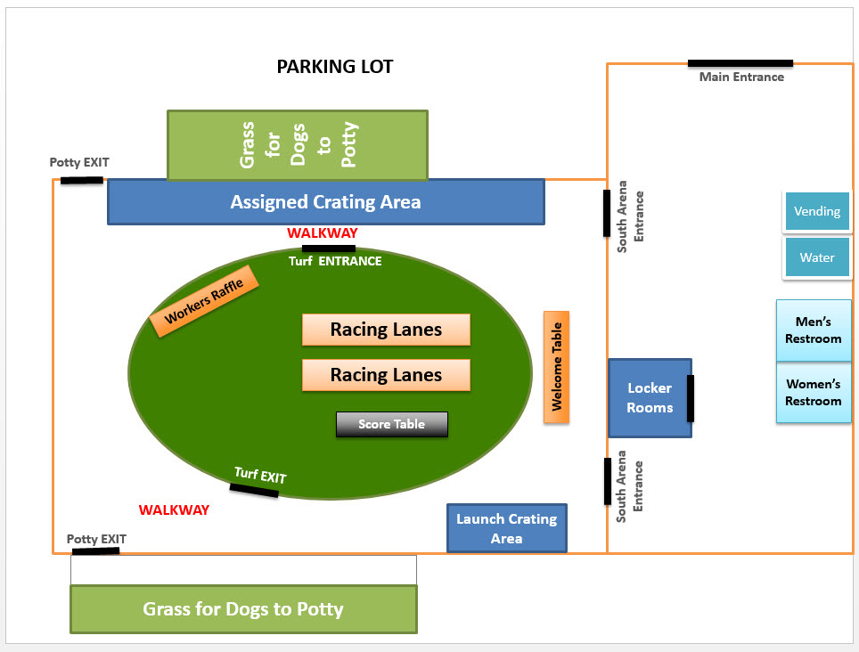

For Dog Emergency:

Wheat Ridge Animal Hospital (24hrs Facility)
3695 Kipling Street
Wheat Ridge, CO 80033
Phone: 303-424-3325
Fax: 303-420-8360
Trip to:
Wheat Ridge Animal Hospital
3695 Kipling St
Wheat Ridge, CO 80033-5738
2.93 miles / 5 minutes
From:,
5724 Oak St, Arvada, , CO 80002-4910

 |  | 1. Start out going south on Oak St toward W 58th Ave. | 0.02 mi
 |  | 2. Take the 1st left onto W 58th Ave.  - If you reach W 56th Pl you've gone about 0.2 miles too far | 0.4 mi
 |  | 3. Turn right onto Kipling St / CO-391.  - Kipling St is 0.1 miles past Miller St | 2.5 mi  4 minutes
 |  | 4. 3695 KIPLING ST is on the right.  - Your destination is 0.1 miles past W 38th Ave  - If you reach W 35th Ave you've gone a little too far
Total Travel Estimate: 2.93 miles - about 5 minutes

For Human’s emergencies:
Lutheran Medical Center
8300 West 38th Avenue,
Wheat Ridge, CO 80033 (303) 425-4500
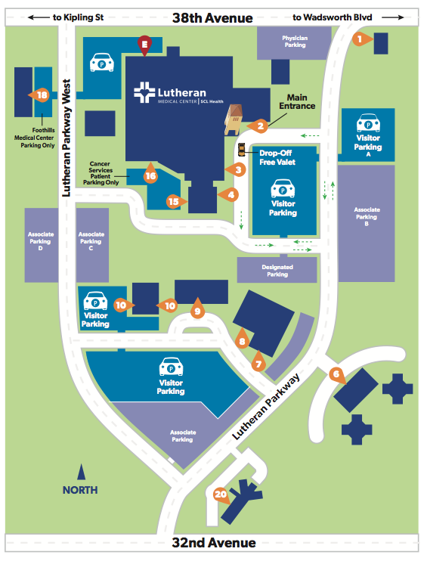

Accommodations:
There are several dog-friendly hotels nearby including:

La Quinta Inn Denver Golden
www.lq.com
3301 Youngfield St. · 4.95 mi
(303) 279-5565

Super 8 Wheat Ridge/Denver West
www.super8.com
4700 Kipling St, Wheat Ridge, CO 80033 · 6.64 mi
(303) 423-4000

RVs Jefferson County Fairgrounds
Golden, Colorado
Phone: (303) 271-6600
Visit Campground Website

Let’s Race!!!



