
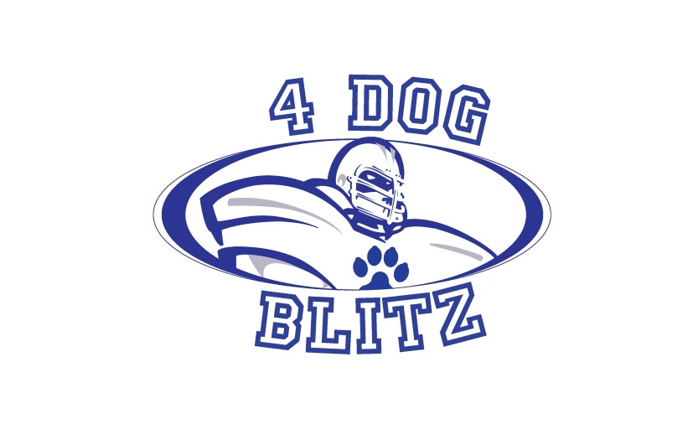
Welcome to Fun in the Sun with a Splash hosted by 4 Dog Blitz! We are very glad you will all be joining us for this outdoor tournament.
Location
Fairmount Park in Golden, CO where we have not had a flyball tournament in years, we are excited to be back!
5222 Quaker St, Golden, CO 80403 keep scrolling for directions and maps
The grass footing is lovely and there are trees available to supplement your shade tents. Please bring any canopies and tents you have for your crating areas to ensure your dogs and your teammates can get out of the sun. The main pavillion will be available for shaded seating and we encourage all to enjoy their lunches at the tables. There will be people camping on location Friday night and Saturday night, while they are not ‘security personnel’, this is a safe neighborhood and you are welcome to leave your crating areas set up overnight. It is recommended that canopies and tents be secured in case of storms. We will have pools for the dogs to cool off in along with some swimmingly good fun to end the day on Saturday! If you have a pool for your dogs please feel free to bring along with a long hose to reach the water spigot. There is no power available, you may bring generators as long as they can be moved a distance away from other participants and crating areas (bring extension cords). There are no food restrictions at the park. As always, please respect local leash laws and only allow dogs to be off leash when actively participating in the tournament racing. Please pick up after your pets and it would be grand if you could pick up any errant messes left in error by others.
Schedule
Friday
Lane set up begins at 5:00 pm
Crating set up begins at 6:30 pm

Saturday and Sunday
Check in at 7:30 am
Measuring at 8:00 am
Racing begins at 8:30 am *if the lanes are wet from overnight rains or dew, we may need to postpone the start of racing.

Format and Racing
Divisions and racing schedules have been posted on the Region 19 website, http://www.region19flyball.com/ as well as on Flyball Geek (ignore the last digit of the race number, we had to add the last digit to get breaks to display) race 1 displays as race 10, race 10 displays as race 100. Saturday http://www.flyballgeek.com/v/542, Sunday http://www.flyballgeek.com/v/543.
There are 30 races each day with 8 breaks scheduled to make sure the dogs get enough resting time in between racing. Lunch breaks will be determined on race day. 1 point will be awarded to the winner of each heat. Races resulting in a tie will award ½ point to each team. Divisional placement tie breakers will be determined by fastest legal time achieved in head to head racing, if still tied the team with the fastest legal time of the day will be declared the winner of the tie. Warmups will be 2 minutes for a team’s first time out for the day, 1 minute for each subsequent race. Flyball Geek will be available online. Links to racing:
Saturday http://www.flyballgeek.com/race/542
Sunday http://www.flyballgeek.com/race/543

Judging

Big thank yous to our judges: Laura Sheldon, head judge and Anthony Pirnat, relief judge. Due to the size of the tournament we need everyone to pitch in with line and box judging as much as possible. Please take advantage of the scheduled racing breaks to allow you to fill the judging chairs to get us out as early as possible. We will have some wonderful prizes for our judging volunteers!

Colleen’s Canine Massage will be onsite both days providing relaxing massages for our canine competitors please stop by and welcome her back from her stint on injured reserve. https://www.facebook.com/ColleensCanineMassageTherapy

Directions/Maps

From I-70 Westbound (Denver, eastern and central corridor suburbs)
Travel I-70 Westbound to CO-58, exit 265
On CO-58 travel .9 miles to the McIntyre St exit 1
Exit northbound, right, on McIntyre 1.5 miles
Turn left on 54th Ave (there is a street light and a sign for Sage Valley Kennels) for .5 miles
Turn left on Quaker St and follow to the end of the paved road, .1 miles, park in the parking lot on your left
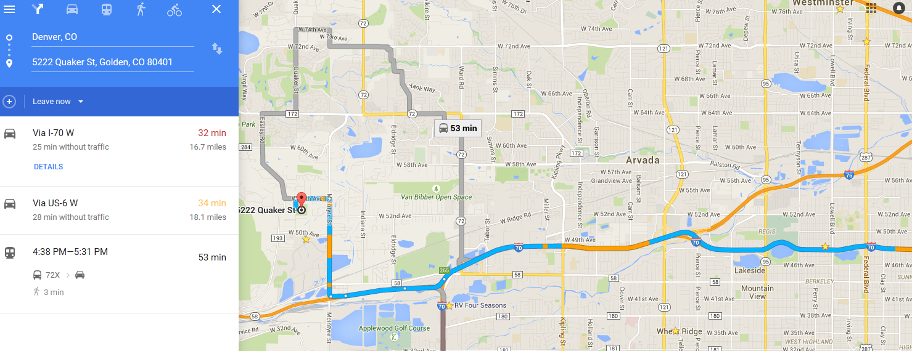

From C-470 Westbound & I-70 Eastbound (Lakewood, Green Mountain, Morrison and southwestern area)
Travel C-470 W to I-70 E (stay right) 5.3 miles
Exit CO-58, exit 265, .9 miles to the McIntyre St exit 1
Exit northbound, right, on McIntyre 1.5 miles
Turn left on 54th Ave (there is a street light and a sign for Sage Valley Kennels) for .5 miles
Turn left on Quaker St and follow to the end of the paved road, .1 miles, park in the parking lot on your left
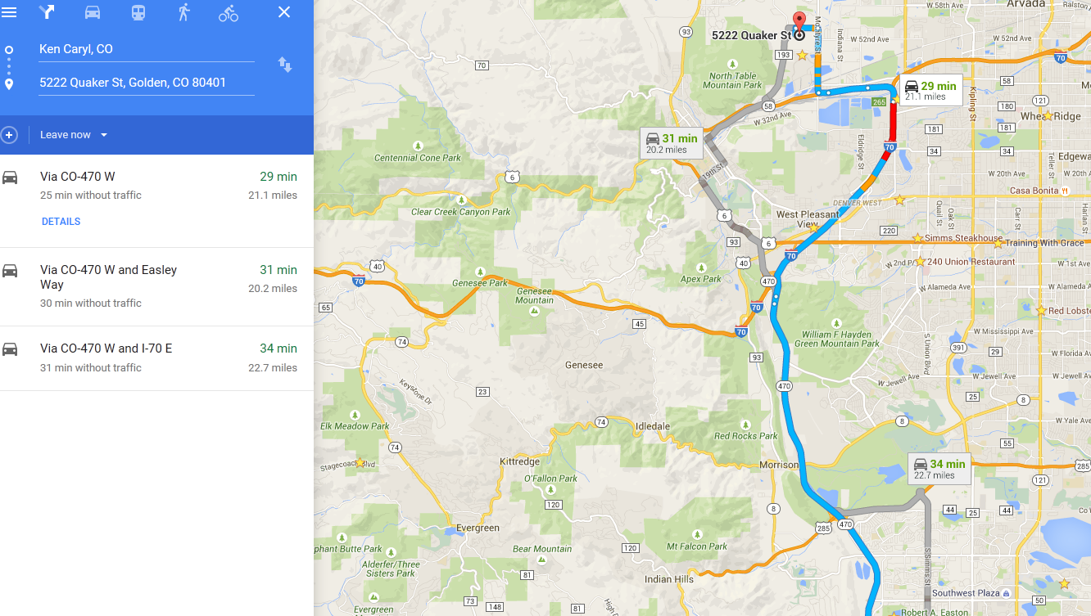

From Hwy 36 (Boulder, Superior, Broomfield, etc)
Travel Eastbound Hwy 36 to McCaslin Blvd south
Follow McCaslin Blvd 3.4 miles to 120th Ave
Turn left on 120th Ave for .3 miles
Turn right on Indiana St for 6.8 miles
Turn right on 64th Ave for .2 miles
Turn left on McIntyre for 1.4 miles
Turn right on 54th Ave (there is a street light and a sign for Sage Valley Kennels) for .5 miles
Turn left on Quaker St and follow to the end of the paved road, .1 miles, park in the parking lot on your left
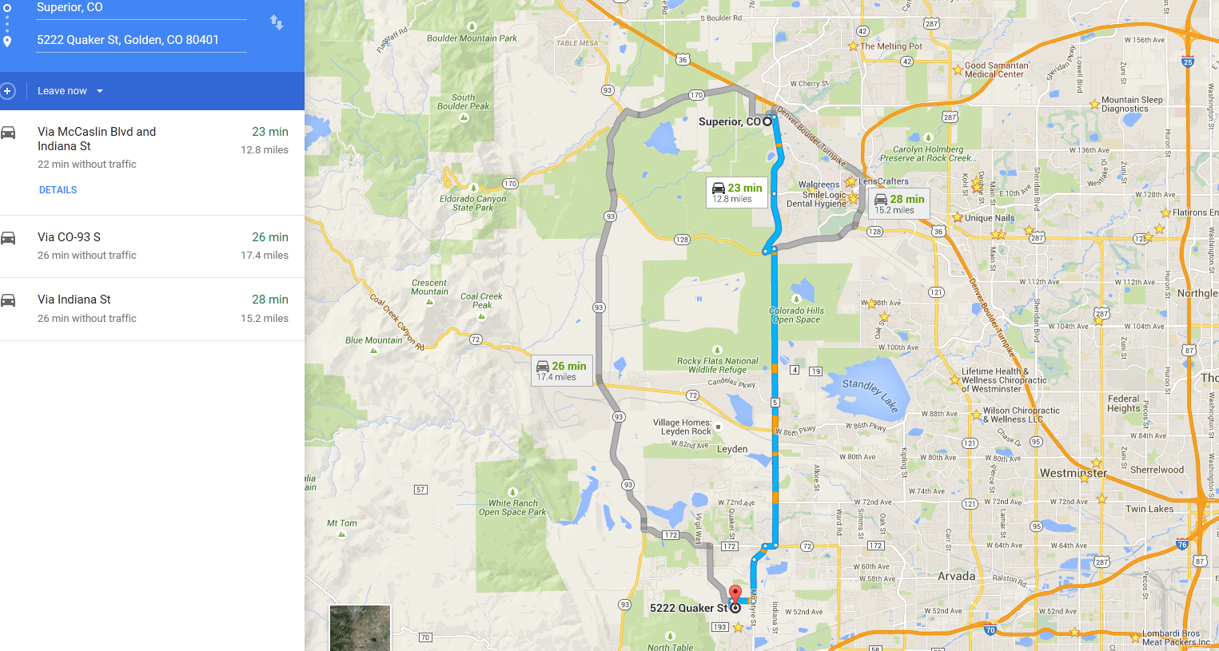

Emergency Medical (humans)
Lutheran Medical Center
8300 W 38th Ave
Wheat Ridge, CO 80033

Directions 15 minutes away
From parking lot exit right on Quaker St to W 54th Ave
Turn right on 54th Ave for .5 miles to McIntyre St
Turn right on McIntyre St for 1.5 miles to CO-58 E
Stay left to exit onto I-70 E for 2.2 miles to exit 267 Kipling St
Keep right onto southbound Kipling St for 1.0 mile to W 38th Ave
Turn left on W 38th Ave for 1.0 miles
Lutheran Medical Center will be on your right, follow the signs to the ER entrance
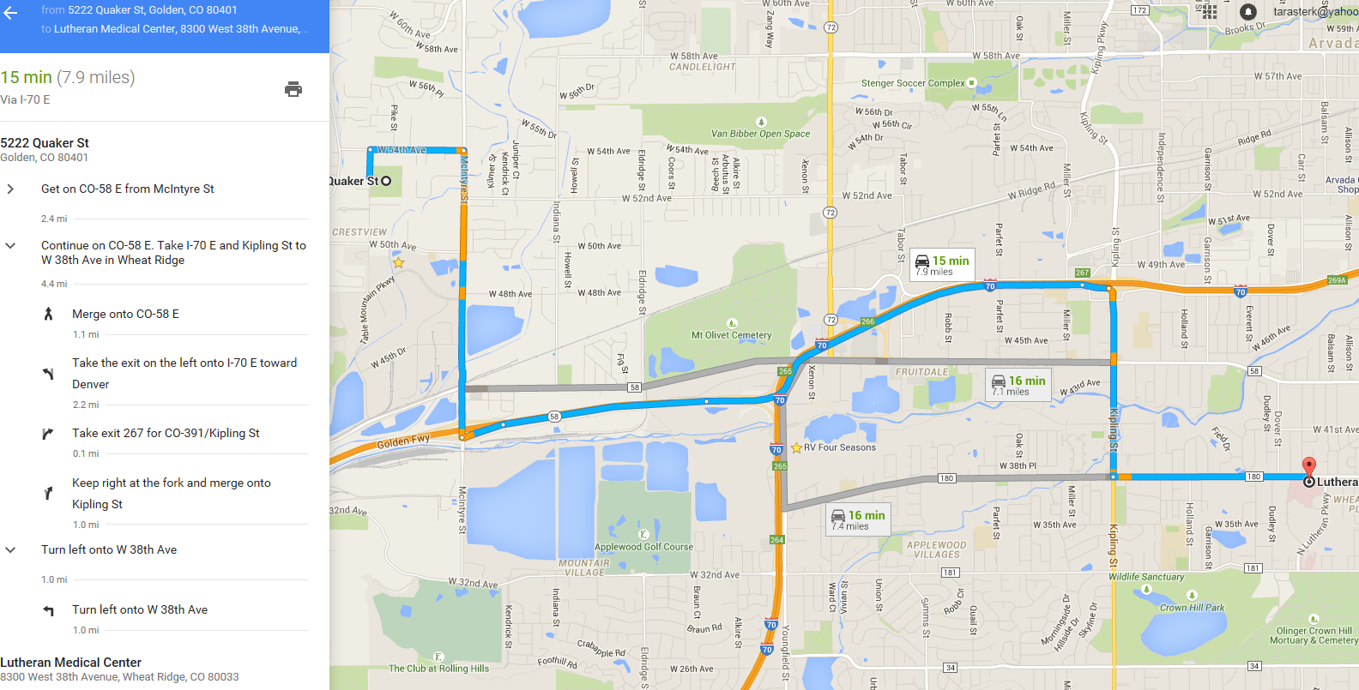

Emergency Veterinary
Wheat Ridge Animal Hospital
3695 Kipling St
Wheat Ridge, CO 80033
(303) 424-3325

Directions 15 minutes away
From parking lot exit right on Quaker St to W 54th Ave
Turn right on 54th Ave for .5 miles to McIntyre St
Turn right on McIntyre St for 1.5 miles to CO-58 E
Stay left to exit onto I-70 E for 2.2 miles to exit 267 Kipling St
Keep right onto southbound Kipling St for 1.2 miles
Wheat Ridge Animal Hospital will be on y our right just after 38th Ave
